MYDESIGN DEMONSTRATION

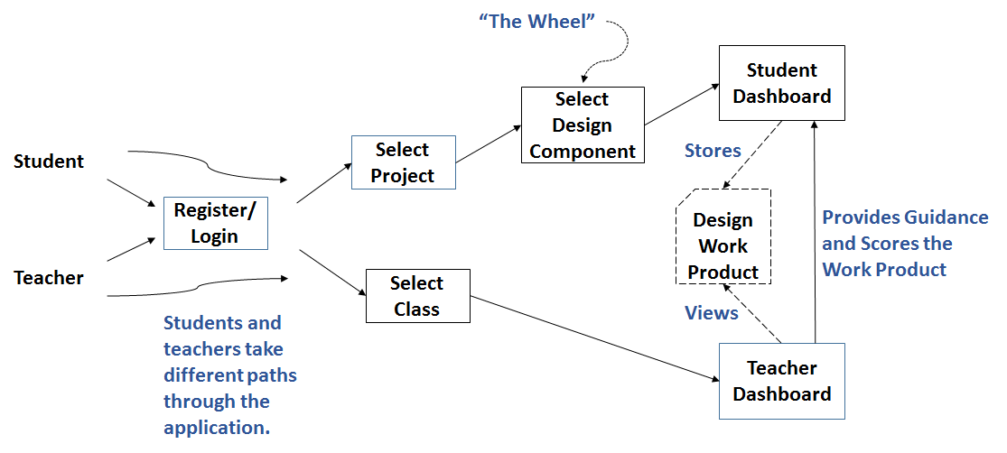

|  |  |  |
| --- | --- | --- |
| **DEMO STEP** | **SCREEN** | **DESCRIPTION** |
| **MyDesign Demonstration** | | |
| 1 | Bring up MyDesign | From local version, right-click on ‘index.html’ and select ‘Open in Firefox’ |
| 2 | Index/Sign Up | Introductory 1 minute video |
| 3 |  | Explain or show Sign Up procedure/screen |
| 4 |  | Log in as ‘dean’; password is pre-loaded |
| 5 | Project Select/Create | Show drop down menus for independent vs assigned projects |
| 6 |  | Explain or show Project Creation screen |
| 7 |  | Select Key Fob project from ‘Assigned’ project drop-down |
| 8 | Wheel, Rubric | Graphical presentation of design process |
| 9 |  | Textual presentation of design process and rubric |
| 10 |  | Design Component 1 animation |
| 11 |  | Select Design Component 1 |
| 12 | Student Dashboard | Layout explanation, including Progress Bar |
| 13 |  | Explain that Design Expectations tab navigates to the design process/rubric textual descriptions |
| 14 |  | MyHome tab – feedback to student of currently selected project and design component |
| 15 |  | MyApps tab – recommended 3rd party apps for student age, project type, and design component; then go back to Wheel (click on logo) |
| 16 | Wheel | Select Design Component 3 |
| 17 | Student Dashboard | MyApps – shows different set of recommended apps; click on TinkerCad and show Keyfob drawing |
| 18 |  | MyResources tab – links to helpful information |
| 19 |  | MyPortfolio tab – save Element G workproduct (Element G Key Fob GCode Drawing File v1) |
| 20 |  | MyPortfolio screen – update of Progress Bar and table of work products released are shown when you go back to the MyDesign tab; may have reselect MyPortfolio to update table. |
| 21 |  | MyProgress and popups – table of work products and grades received; may have to reselect to refresh table; table should have just two rows |
| 22 |  | Collaborators – table of class teammates; click red button |
| 23 |  | MyMentors – table of teachers & Exit |
|  |  |  |
| 24 | Bring up MyDesign | From local version, right-click on ‘index.html’ and select ‘Open in Firefox’ |
| 25 | Log In | Select ‘leigh’ as username; ‘abts’ as password |
| 26 | Class Select/Create | Class drop-down and creation process; select Class #1 |
| 27 | Teacher Dashboard | Dashboard Layout and Home: class name and description |
| 28 |  | Reference the Rubric – design process/rubric textual descriptions |
| 29 |  | MyClass – add Teddy |
| 30 |  | MyTeams – add Team E and assign Joe & Teddy |
| 31 |  | Projects –project creation process; add ‘MyDesign Key Fob’ to Teddy and Joe |
| 32 |  | Design Review – table with student status; review Dean’s new work product, score, comment and save |
| 33 |  | Design Review Results – table or reviewed work product; select Dean’s newly reviewed work product review results; Exit |